CENWP-OD-B 31 July 2023

MEMORANDUM FOR THE RECORD

SUBJECT: 23BON070 MFR Cascades Island LPS RB4 Pacific Lamprey Mortality

On the morning of 31 July, Project Biologists discovered one adult Pacific Lamprey mortality in the Cascades Island LPS Rest Box 4 (CI LPS RB4). The fish was scanned for PIT tags, inspected, and returned to the river.

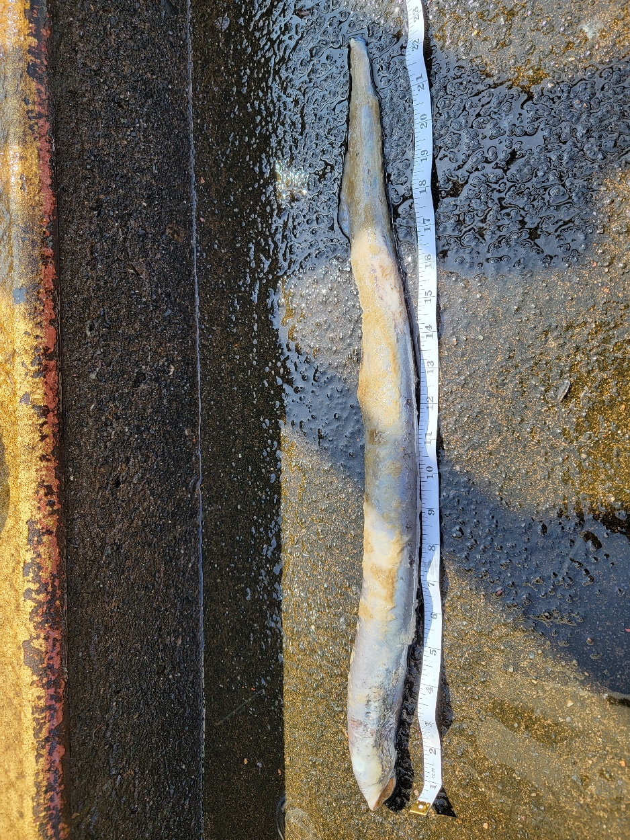
- Species – Pacific Lamprey (Entosphenus tridentatus)
- Origin – Unknown
- Length – 56.5 cm
- Marks and tags – None
- Marks and Injuries found on carcass – General decay
- Cause and Time of Death – Unknown
- Future and Preventative Measures – None

Sincerely,
BON Project Fisheries

